EXPERIMENT 7

Name: shantanu swaraj
Sap id:500097021

q.1>
Write algorithm and C program, compile, execute and test the code using Linux C compiler with suitable test cases
1.1>
Sort the List of Elements stored in a Linked List using the Bubble sort algorithm.

Code:
#include<stdio.h>
#include<stdlib.h>

struct Node
{
int data;
struct Node *next;
};

void insertAtTheBegin(struct Node **start_ref, int data);

void bubbleSort(struct Node *start);

void swap(struct Node *a, struct Node *b);

void printList(struct Node *start);

int main()
{
int a[] = {11,32,56,2,8,9};
int size, i;
struct Node *head = NULL;

for (i = 0; i< 6; i++)
insertAtTheBegin(&head, a[i]);

printf("\n Linked list before sorting ");
printList(head);

bubbleSort(head);

printf("\n Linked list after sorting ");
printList(head);

getchar();
return 0;
}

void insertAtTheBegin(struct Node **start_ref, int data)
{
struct Node *ptr1 = (struct Node*)malloc(sizeof(struct Node));
ptr1->data = data;
ptr1->next = *start_ref;
*start_ref = ptr1;
}

void printList(struct Node *start)
{
struct Node *temp = start;
printf("\n");
while (temp!=NULL)
{
printf("%d ", temp->data);
temp = temp->next;
}
}

void bubbleSort(struct Node *head)
{
int swapp, i;
struct Node *ptr1;
struct Node *lptr = NULL;

if (head == NULL)
return;

do
{
swapp = 0;
ptr1 = head;

while (ptr1->next != lptr)
{
if (ptr1->data > ptr1->next->data)
{
swap(ptr1, ptr1->next);
swapp = 1;
}
ptr1 = ptr1->next;
}
lptr = ptr1;
}
while (swapp);
}

void swap(struct Node *a, struct Node *b)
{
int temp = a->data;
a->data = b->data;
b->data = temp;
}

Output:
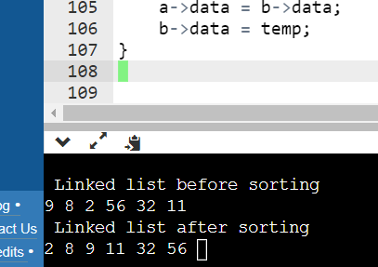

1.2> <a>insertion sort
Code:
#include<stdio.h>
#include<conio.h>

void main()
{

int i, j,n,key,arr[20];
printf("Enter number of elements to use:");
scanf("%d",&n);
printf("Enter %d elements: ",n);

// This loop would store the input numbers in array
for(i=0;i<n;i++)
scanf("%d",&arr[i]);

// Implementation of insertion sort algorithm
for(i=1;i<n;i++){
key=arr[i];
j=i-1;
while((key<arr[j])&&(j>=0)){
arr[j+1]=arr[j];
j=j-1;
}
arr[j+1]=key;
}

printf("Sorted elements: ");
for(i=0;i<n;i++)
printf(" %d",arr[i]);
getch();
}

Output:
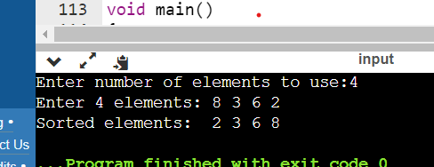

1.2><b>
Selection sort :

Code:
#include<stdio.h>
#include<conio.h>
void main()
{
int i,j,n, temp,arr[20];

printf("Enter Number of elements to use: ");
scanf("%d",&n);
printf("Enter %d elements: ",n);

// Loop to get the elements stored in array
for(i=0;i<n;i++)
scanf("%d",&arr[i]);

// Logic of selection sort algorithm
for(i=0;i<n;i++)
{
for(j=i+1;j<n;j++)
{
if(arr[i]>arr[j])
{
temp=arr[i];
arr[i]=arr[j];
arr[j]=temp;
}
}
}
printf("Sorted elements: ");
for(i=0;i<n;i++)
printf(" %d",arr[i]);
getch();
}

Output:
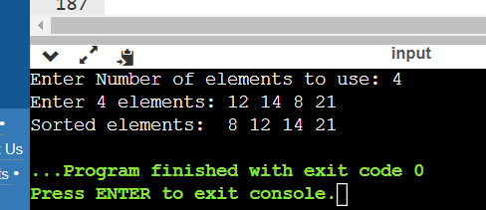

q.2><c> merge sort

code:
#include<stdio.h>
#include<conio.h>
void mergesort(int a[],int i,int j);
void merge(int a[],int i1,int j1,int i2,int j2);

void main()
{
int a[30],n,i;
printf("Enter no of elements:");
scanf("%d",&n);
printf("Enter array elements:");

for(i=0;i<n;i++)
scanf("%d",&a[i]);

mergesort(a,0,n-1);

printf("\nSorted array is :");
for(i=0;i<n;i++)
printf("%d ",a[i]);

getch();
}

void mergesort(int a[],int i,int j)
{
int mid;

if(i<j)
{
mid=(i+j)/2;

//left recursion
mergesort(a,i,mid);

//right recursion
mergesort(a,mid+1,j);

merge(a,i,mid,mid+1,j);
}
}

void merge(int a[],int i1,int j1,int i2,int j2)
{
int temp[50];
int i,j,k;
i=i1;
j=i2;
k=0;

while(i<=j1 && j<=j2)
{
if(a[i]<a[j])
temp[k++]=a[i++];
else
temp[k++]=a[j++];
}

while(i<=j1)
temp[k++]=a[i++];

while(j<=j2)
temp[k++]=a[j++];

for(i=i1,j=0;i<=j2;i++,j++)
a[i]=temp[j];
}
Output:
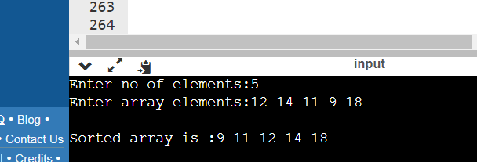

q.2><d>
quick sort
code:
#include<stdio.h>
#include<conio.h>

void quicksort(int arr[100], int first, int last);

void main()
{
int i,n,arr[20];

printf("Enter the number of elements to sort: ");
scanf("%d",&n);

printf("Enter %d elements: ",n);
for(i=0;i<n;i++)
scanf("%d",&arr[i]);

quicksort(arr,0,n-1);
printf("Sorted elements: ");
for(i=0;i<n;i++)
printf(" %d",arr[i]);

getch();
}

void quicksort(int arr[100],int first,int last)
{
int i, j, pivot, temp;

if(first<last){
pivot=first;
i=first;
j=last;

while(i<j)
{
while(arr[i]<=arr[pivot]&&i<last)
i++;
while(arr[j]>arr[pivot])
j--;
if(i<j){
temp=arr[i];
arr[i]=arr[j];
arr[j]=temp;
}
}

temp=arr[pivot];
arr[pivot]=arr[j];
arr[j]=temp;
quicksort(arr,first,j-1);
quicksort(arr,j+1,last);

}
}

Output:
